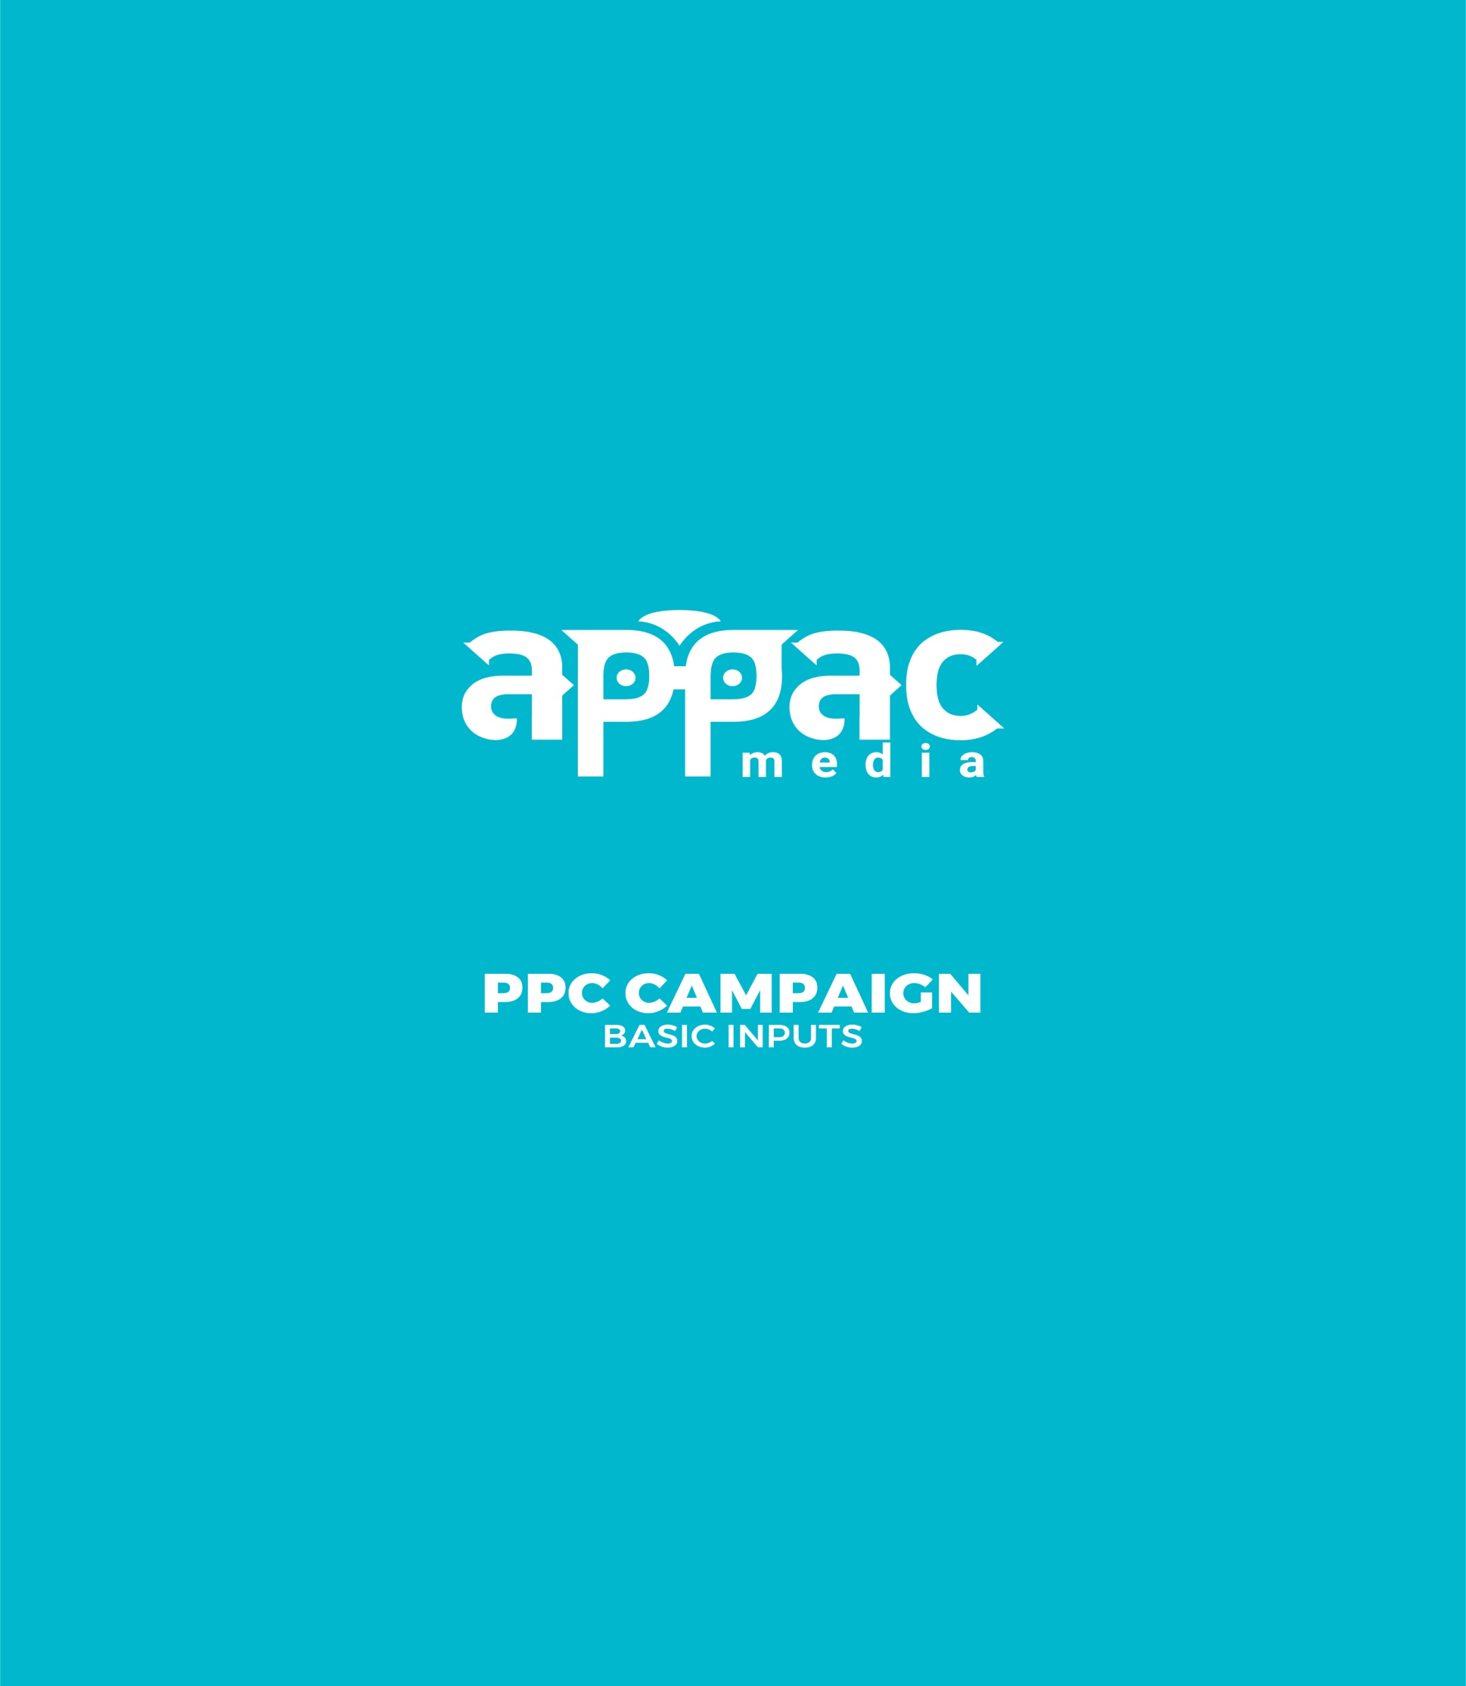
K Express
Company Name

www.kexpresscjb.com
Website

Target Products

International Courier

Landing Page URL

Whats is Your Target Products

Whats is Your Target Locations

Coimbatore

Who is your target audience?

All

Who are your competitors?

https://www.garudavega.com/
https://oscarexpress.in/
https://www.nrineeds.in/

Any suggestions for keywords which can be given to the campaign developer?

Dhl Courier
Dhl Coimbatore
International Courier
Fedex Courier

What is the goal of the campaign?

Get calls

Have you previously done a PPC campaign?

Yes No

If yes, please provide username and password to access the data

User Name

Password

Customer ID

We value your trust in our




Nathal Srinivasan

Media Marketing Manager
M - +919342902803| E -marketing@appacmedia.com| Ph: +91422-2477555

APPAC MEDIATECH PVT. LTD.

#204,2nd Floor,

Aathisree Towers,D.B.Road,R.S.Puram,Coimbatore – 641002

www.appacmedia.com

